Invariant representation of information and information quantity in image processing tasks¹
M. V. Kharinov²

²St. Petersburg Institute for Informatics and Automation of RAS,
14–th line, 39, 199178, St. Petersburg, Russia
khar@iias.spb.su
A model of signal (image) containing the information codes in its own digital «virtual» memory independently of stretching, packing according to intensity and other prescribed image transformations is proposed. Virtual memory cells contain the pixel values of information representation. Storage elements of virtual memory cells are classified into fixed and modifiable ones so that arbitrary variation of the latter doesn’t cause image destruction. The number of modifiable storage elements juxtaposed with image pixels is regarded as the information quantity. The model applications to image recognition, document protection and other tasks are discussed.

Introduction
It is known that in modern informatics, particularly in signal (image) processing, the information concept is insufficiently structured and formalized so far [1]. The concepts of information, signal and information sense are not clearly demarcated of one another. Considerations of the problem of information quantity usually avoid starting with qualification of concept of information itself. The problem of experimental verification of information quantity assigned to everyone pixel is often neglected as well.
The tasks of image processing without any a priori knowledge of the image content necessitate more accurate interpretation of information concept. That interpretation is needed, for example, to solve the blind steganography task consisting of reversible embedding one signal into another on conditions that both signals are unknown upon reception. More accurate interpretation of information concept is also needed to solve the common image recognition problem by attributing the complementary features to pixels in addition to intensities for unified object detection and identification.
To facilitate an interpretation of information concept and solve of appointed tasks we develop a model presenting the image as a memorizing medium and peculiar container or tool for coded information storage and transmission [2]. According to our model an image like a computer possesses its own digital memory (so called «virtual» memory) which is able to store the coded information independently of prescribed image transformations.
Peculiarities of virtual memory
Virtual memory is defined as an abstract matrix of cells containing the information codes which are extracted from an image without the intensity order alteration. The information quantities of pixels are unambiguously related to information codes. The cells of virtual memory are juxtaposed with pixels in one-to-one relationship. Unlike the memory cells of usual computer the virtual memory cells contain no bits but trits assigning to 0 or ±1. The cells of virtual memory consist of equal number of storage elements (trits) similarly to computer memory cells. But the number of trits of the virtual memory cell depends on image content and usually exceeds the number of bits in source computer image representation, say, twice. The trits of the same position constitute a channel of virtual memory just as the computer bits form bit-planes accordingly to their position in bytes. The storage elements of virtual memory are classified into modifiable (read-write) trits, possessing variable values by analogy with computer bits, and fixed (read-only) trits, possessing invariable values as it is specified in the following table:

Table. Units of information representation and storage
Units  Attributes | Bit | Trit
Position (channel) | 0,1.2, …, 7 | 0,1.2, …, Ch
Value | 0, 1 | 0, ±1
Access | RW | R, RW

Ch herein denotes the number of channels of image virtual memory, R и RW denotes fixed and modifiable storage elements respectively.
The trits are classified into modifiable and fixed so that the latter support the image restoration in some simplified (segmented) form in spite of arbitrary variation of modifiable ones. It’s admissible in some approximation to assume that fixed trits contain mainly visual information (codes of visible information) and modifiable trits contain the codes of noteless information. Zero trits are always regarded as fixed. Two operations for modification of variable trit values are defined. One operation is reduced to reversing of trit value. Another fixation (weaving) operation consists in transformation of variable trit into fixed one. The modifications of virtual memory trits are encoded with appropriate transformations of image pixels.
Owing to variations of modifiable trits the reliably writing operations of some message information to virtual memory are provided. The message is treated as ternary one consisting of 0 and ±1. Zero valued message elementary codes resulting from reading of fixed trits are interpreted as indefinite and cause the fixation operations during the message writing.
Virtual Memory Model
The virtual memory is built according to the generalized dichotomy algorithm [2] reducing to iterative splitting of intensity scale into the ranges and forming the sequence of embedding partitions of intensity scale on the conditions of equiprobable pixel distribution.
The hierarchy of ranges for given pixel is shown in Fig.1 (Note that at each iteration only one boundary of range converges to pixel value).

Intensity scale
Intensity of i-th pixel
−11−110
i-th cell of virtual memory

Number of intensity scale partition
Fig. 1. The calculation of the virtual memory cell juxtaposed with given pixel

Each iteration of splitting of ranges results in calculating the set of trits of next virtual memory channel. If the intensity of a given pixel at current iteration belongs to the range of greater intensities then the associated trit is assigned to 1. If the pixel intensity belongs to the lower intensity range then the associated trit is set to -1. Zero value is assigned to a trit in degenerated case of singular intensity forming a separate range.
The toggle of trit to its opposite value is performed by shifting the relative pixel intensity into alternative range. Zero trits are always ranked as fixed. The trits juxtaposed with boundary intensities are also classified as fixed. The remainder trits are classified as modifiable. The fixation (weaving) of value of trit from given virtual memory channel is performed by assigning the pixel intensity to the boundary value of appropriate intensity range.
The quantity of information contained in given pixel is defined as the number of modifiable trits describing the volume of data which can be written into associated cell of virtual memory. The decrease of information quantities in the virtual memory cells by fixation of trits comes out in decreasing of the number of different image pixels.
The sequential writing of information codes into modifiable trits of virtual memory is performed from most significant to less significant channels. The modification of less significant channels doesn’t change the preceding message which is already written, but it changes the current partition of intensity scale and destroys the information in the channels to be processed. Therefore the writing of desired message into each current channel is followed by the restoration of information codes in less significant channels and repeatedly resumed until the image is stayed invariable so that the strict limit of the sequence of representations is attained and the virtual memory filling with prescribed values of variable trits is obtained.
Experimental results
The results of the calculation of information and information quantity representations of standard image are presented in Fig. 2.

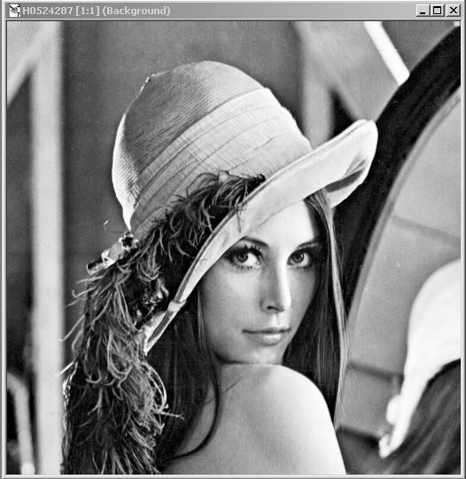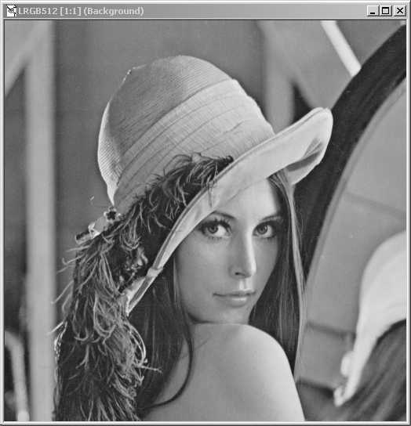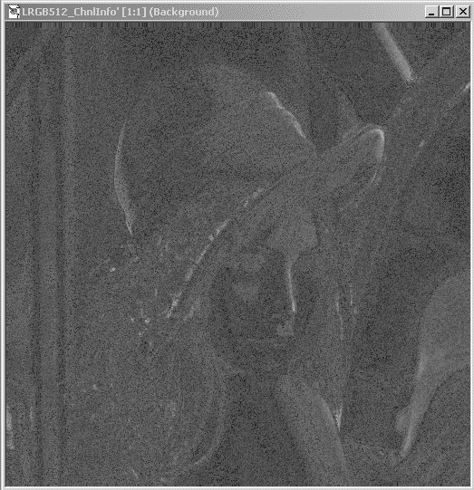
Fig. 2. Invariant informational representations of an image: representation of information (left); representation of information quantity constituted of proportional to the informational quantities pixel values (right); and source image (middle). The representations are a normalized fitting to the effective range of intensity

The representation of information (or in other words information representation) is invariant due to invariability in respect to stretching, packing according to intensity and other isomorphic image transformations conserving source intensity order. The representation of information treated as the source image is stayed invariable under the repeated transformation into representation of information (in other words the image conversion into representation of information is an idempotent transformation). The information representation is invariant isomorphic representation of the source image as it maintains the original intensity relations (more, equal or less) between pixels and doesn’t depend on isomorphic transformation of the image into isomorphic representation.

The representation of information quantity is calculated in accordance with the information representation. Apart from isomorphic image transformations it doesn’t depend on positive-to-negative image reversal. It may be used along with source image or invariant image representation for object detection by means of usual pixel values threshold analysis exemplified in the report with cartographical image processing task. Furthermore, as the representation of information quantity specifies the possible decreasing of information quantities of pixels, it provides another threshold technique which is carried out for object detection or identification by means of fixation (weaving) of virtual memory trits. Fig. 3 illustrates the segmentation of standard image in informational representations for object detection by means of prescribed decreasing of pixel information quantities.

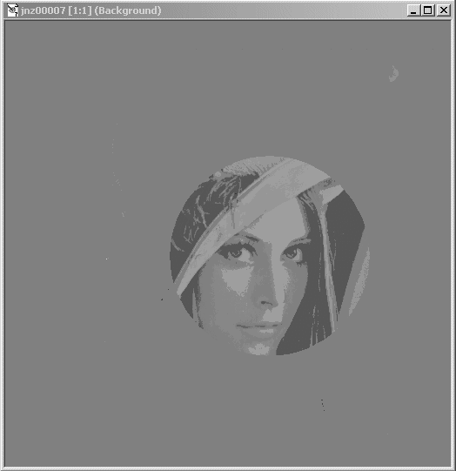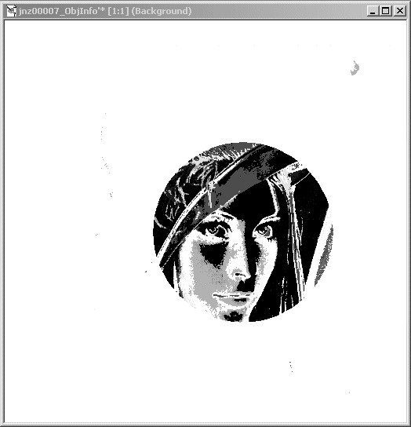
Fig. 3. Generation of an image with specified information quantity distribution: source image (left); the image with reduced quantities of information outside the circle (middle); the negatived representation of information quantity (right)

To demonstrate the application of our model to the tasks of information assurance we use the comprehensible example of steganographycal protection of paper banknotes (Fig. 4).
An example of composite image containing the message written to one of the least significant channels of virtual memory is shown in the upper left corner of Fig. 4. The embedded ternary message initially produced by threshold of standard image (fig. 2) is shown on the right side. The content of two most significant virtual memory channels of source image is placed bellow.

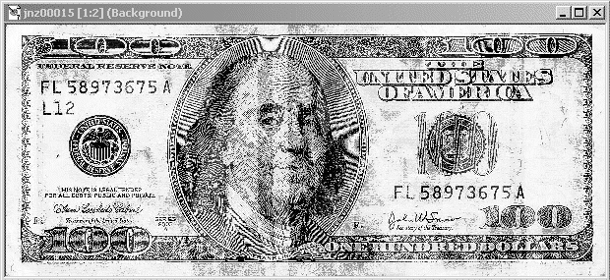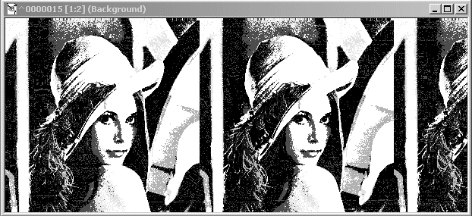

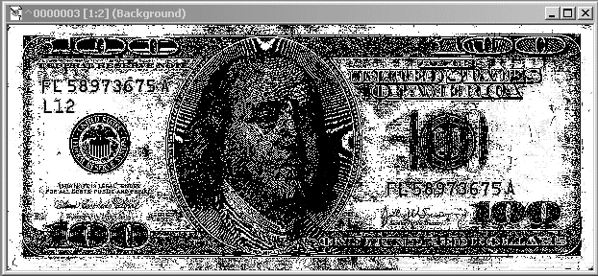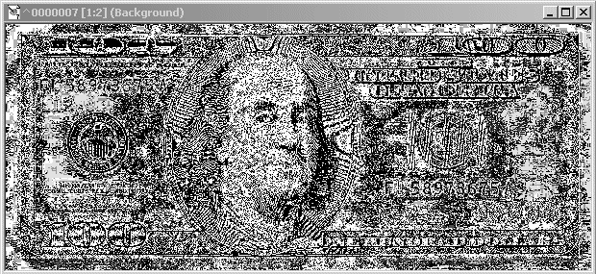
Fig. 4. Application of digital virtual memory for protecting message embedding: image and embedded message (upper ones); most significant ternary planes of virtual memory (lower ones)

For individual banknote protection avoiding the creation of appropriate data base it is useful to correct the printing image by means of embedding the structural pattern of the current paper sheet (outlines of paper fibers, implanted threads, inclusions etc.) into image virtual memory to exclude falsification anchoring the concrete physical carrier in the image.
Beside the mentioned examples another applications of our model are also discussed in the report.
Conclusion
In the report we justify the vernacular conception of information as the sequence of symbols, codes, traces or some another imprints, remaining on paper, in computer memory or in any another physical carrier and in virtual memory of an image as well. We build the computer interpretation of information concept in the frameworks of combinatorial approach of A. N. Kolmogorov, who stated that it is not obligatory to content information concept with the concept of probability [3]. The quantity of pixel information we estimate in accordance with structural approach of F. E. Temnikov, who reduced the information quantity calculation to ordinary counting of some signal elements [4,5].
The idea of ternary virtual memory constructing with the image components seems to pay-off. But owing to N. P. Brusentsov it is notorious almost a half century that just the ternary memory is effective for processing of digital data [6,7]. We hope that the model of virtual memory will be useful for better understanding of mentioned well-known scientific solutions.
References
- I.B. Gurevich The Descriptive approach to Image Analysis. Next Steps // Pattern Recognition and Image Analysis: New Information Technologies (PRIA–7–2004) / Proc. of the 7-th. Int. Conf., - St.Petersburg, - 18-23 October 2004.
- M.V. Kharinov Storage and Adaptive Processing of Digital Image Information /Ed. by R.M. Yusupov. -
St. Petersburg University Press, - 2006. . - 138 p. (in Russian).
- A.N. Kolmogorov Three Approaches for Defining the Concept of Information Quantity // Problems of Information Transmission. – 1965. - Issue 1, vol. 1. -P. 3–8. (in Russian).
- F.E. Temnikov, Informatics // Proceedings of higher education institutes. Electromechanics. – 1963. - No.1, - P. 1277. (in Russian).
- F.E. Temnikov, V.A. Afonin, V.I. Dmitriev Theoretical Foundation of Informational Engineering. - М.: Energiya, - 1979. - 512 с. (in Russian).
- N.P. Brusentsov Computing Machine “Setun’” produced by the Moscow State University. In the book: Novel Designs in the Field of Computing Mathematics and Computing Equipment. -Kiev, -1960. - P. 226-234. (in Russian).
- N.P. Brusentsov Restoration of Logic. - M.: Novoe Tysyacheletie, - 2005. - 165 p. (in Russian).

